Cardinal Numerals

✅ Definition:
# Source: AI Source: Provided by: [Data Path: Persons Table -> ID Column: 1, Name_En Column: Motasem Essam] -> From: [Chatgpt (GPT-4-turbo)] on [7/28/2025]
Cardinal numerals are words that express exact quantity or how many of something there are.
They answer the question: "How many?"

🧩 Examples of Cardinal Numerals:
# Source: AI Source: Provided by: [Data Path: Persons Table -> ID Column: 1, Name_En Column: Motasem Essam] -> From: [Chatgpt (GPT-4-turbo)] on [7/28/2025]
- one, two, three, four, five
- ten, twenty, fifty
- one hundred, one thousand
- zero, a million, billions

✏️ Examples in Sentences:
# Source: AI Source: Provided by: [Data Path: Persons Table -> ID Column: 1, Name_En Column: Motasem Essam] -> From: [Chatgpt (GPT-4-turbo)] on [7/28/2025]
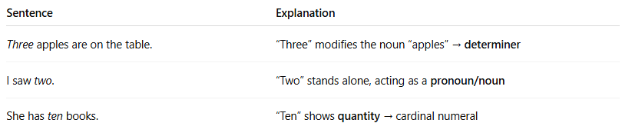
Sentence | Explanation
Three apples are on the table. | “Three” modifies the noun “apples” → determiner
I saw two. | “Two” stands alone, acting as a pronoun/noun
She has ten books. | “Ten” shows quantity → cardinal numeral

📌 Grammatical Function:
# Source: AI Source: Provided by: [Data Path: Persons Table -> ID Column: 1, Name_En Column: Motasem Essam] -> From: [Chatgpt (GPT-4-turbo)] on [7/28/2025]
Cardinal numerals can function as:
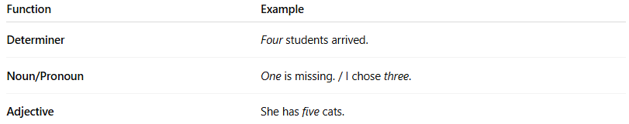
Function | Example
Determiner | Four students arrived.
Noun/Pronoun | One is missing. / I chose three.
Adjective | She has five cats.

🔍 Properties of Cardinal Numerals:
# Source: AI Source: Provided by: [Data Path: Persons Table -> ID Column: 1, Name_En Column: Motasem Essam] -> From: [Chatgpt (GPT-4-turbo)] on [7/28/2025]
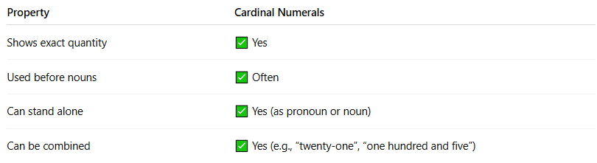
Property | Cardinal Numerals
Shows exact quantity | ✅ Yes
Used before nouns | ✅ Often
Can stand alone | ✅ Yes (as pronoun or noun)
Can be combined | ✅ Yes (e.g., “twenty-one”, “one hundred and five”)

⚠️ Note:
# Source: AI Source: Provided by: [Data Path: Persons Table -> ID Column: 1, Name_En Column: Motasem Essam] -> From: [Chatgpt (GPT-4-turbo)] on [7/28/2025]
- Cardinals are different from ordinals (which show order: first, second, third).
- Cardinals are also different from quantifiers like some, many, few (which are not always exact).

🧠 Summary:
# Source: AI Source: Provided by: [Data Path: Persons Table -> ID Column: 1, Name_En Column: Motasem Essam] -> From: [Chatgpt (GPT-4-turbo)] on [7/28/2025]
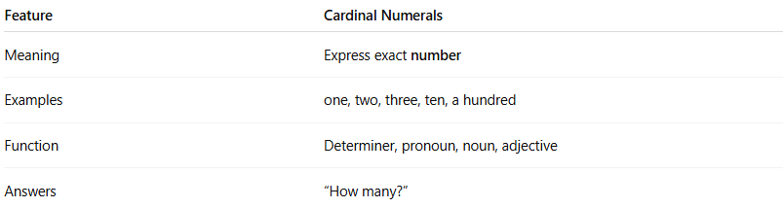
Feature | Cardinal Numerals
Meaning | Express exact number
Examples | one, two, three, ten, a hundred
Function | Determiner, pronoun, noun, adjective
Answers | “How many?”

